


CSIT-25-S1-19: Developing recommendation app for diet and nutrition

FYP-25-S1-19: User Requirement Specification

Team

Student Name | UOW ID | Student E-mail
William Tay Zhi Hong | 8039239 | wzhtay001@mymail.sim.edu.sg
Pei Sai Yong | 8762247 | sypei001@mymail.sim.edu.sg
Teo Zuo Jun Anders | 8039094 | zjateo002@mymail.sim.edu.sg
Toh Chin Yang Nicholas | 8106721 | cyntoh003@mymail.sim.edu.sg
Peh Yi Xiong | 8080987 | yxpeh001@mymail.sim.edu.sg

Supervisor:
Mr Premrajan P

Project Website:
https://wzhtay001.wixsite.com/nutriscope
1. Introduction 3
1.1 Purpose 3
1.2 Intended audience and reading suggestions 3
1.3 Project Scope 3
2. Overall Description 4
2.1 Project Perspective 4
2.3 User Classes and Characteristics 17
2.4 Operating Environment 20
2.5 Design and Implementation Constraints 20
2.6 User Documentation 20
2.7 Assumption and Dependencies 21
3. System Features 22
3.1 Use Case Diagram - Unregistered User 22
3.1.1 User Stories - Unregistered User 23
3.1.2 Use Case Description - Unregistered User 23
3.2 Use Case Diagram - Free User 27
3.2 User Stories- Free User 28
3.2 Use Case Descriptions- Free User 29
3.3 Use Case Diagram - Premium User 41
3.3 User Stories- Premium User 43
3.3 Use Case Descriptions- Premium User 44
3.4 Use Case Diagram - Nutritionist 53
3.4 User Stories - Nutritionist 54
3.4 Use Case Descriptions - Nutritionist 55
3.5 Use Case Diagram - System Admin 64
3.5 User Stories- System Admin 64
3.5 Use Case Descriptions- System Admin 65
4. Non-functional Requirements 70
4.1 Security Requirements 70
4.2 Reliability Requirements 70
4.3 Performance Requirements 70
4.4 Maintainability Requirements 70
4.5 Scalability Requirements 70
4.6 Usability Requirements 71

1. Introduction

1.1 Purpose

The purpose of this user requirement specification document is to help assist the team in the approval of the “Developing recommendation app for diet and nutrition” project. This document will aid us in the decision of the requirements of our project. Also, the features of each user will be implemented with the requirements that we have decided on.

1.2 Intended audience and reading suggestions

This user requirement specification document intended audience is for the people who will be involved in this project. This includes us, the people who are working on the project, along with both our supervisor, Mr Premrajan P and our assessor, Dr Loo Poh Kok. Mandatory knowledge with regards to Information Technology is required to be able to read through this document.

1.3 Project Scope

The scope of this project is to enable users to define and manage their dietary goals conveniently on a mobile application with features such as daily calorie limits, weight and nutrition tracking. User efforts will be supplemented with expert guidance by integrating nutritionist support, including recipe validation, personalized diet plans and consultations. The application has free and paid memberships.

2. Overall Description

2.1 Project Perspective
The product we are developing is a mobile application designed to assist users in managing their dietary goals effectively. This application will be available on both Android and iOS platforms, ensuring accessibility for a wide range of users. It caters to individuals seeking personalized meal recommendations, calorie tracking, and expert nutritional guidance
Unregistered users can visit our project website to find out more about the features of the application and pricing. They can also download the app which they will then be greeted with a quick slideshow of our features and pricing. They can then choose to sign up as either a free user or nutritionist, the latter needing additional verification by an administrator.
Users can define and manage their dietary goals, such as setting daily calorie limits and adjusting them based on progress. The app provides personalized meal recommendations aligned with user preferences and dietary restrictions. Additionally, it facilitates tracking of daily calorie intake and offers comprehensive reports to help users monitor their progress.
Users can log their meals manually or select from a predefined list, ensuring accurate tracking of calorie intake. They can also take a picture of the food item which will show how many calories are in a dish. To further enhance user experience, the app includes a diary feature for daily and monthly calorie tracking and generates reports on dietary habits. Users will also have access to nutritionist support for expert guidance, personalized diet plans, and recipe validation.
Nutritionists will have dedicated tools to manage their clients and validate dietary recommendations. They can log in and out securely, update their profiles, and deactivate their accounts if needed. They will have access to a dashboard displaying all clients, their nutrition logs, and their progress. Nutritionists can review, modify, and validate client-submitted recipes to ensure they meet dietary standards. They can also create and update customized diet plans tailored to each client's needs. To facilitate interaction, they can engage in real-time text-based chats with users, offering dietary advice and support. Additionally, nutritionists can provide ratings and reviews for the app, contributing to its ongoing improvement.
Administrators will oversee user accounts and app content management. They can view and manage user accounts, including suspending accounts that violate policies. They have the ability to validate nutritionist signups, ensuring only qualified professionals provide dietary guidance. Admins can also edit and update the project website, ensuring that all information remains accurate and up to date. Furthermore, they can review user feedback and ratings to assess overall user satisfaction and improve the application accordingly.

.2.2 Product Features
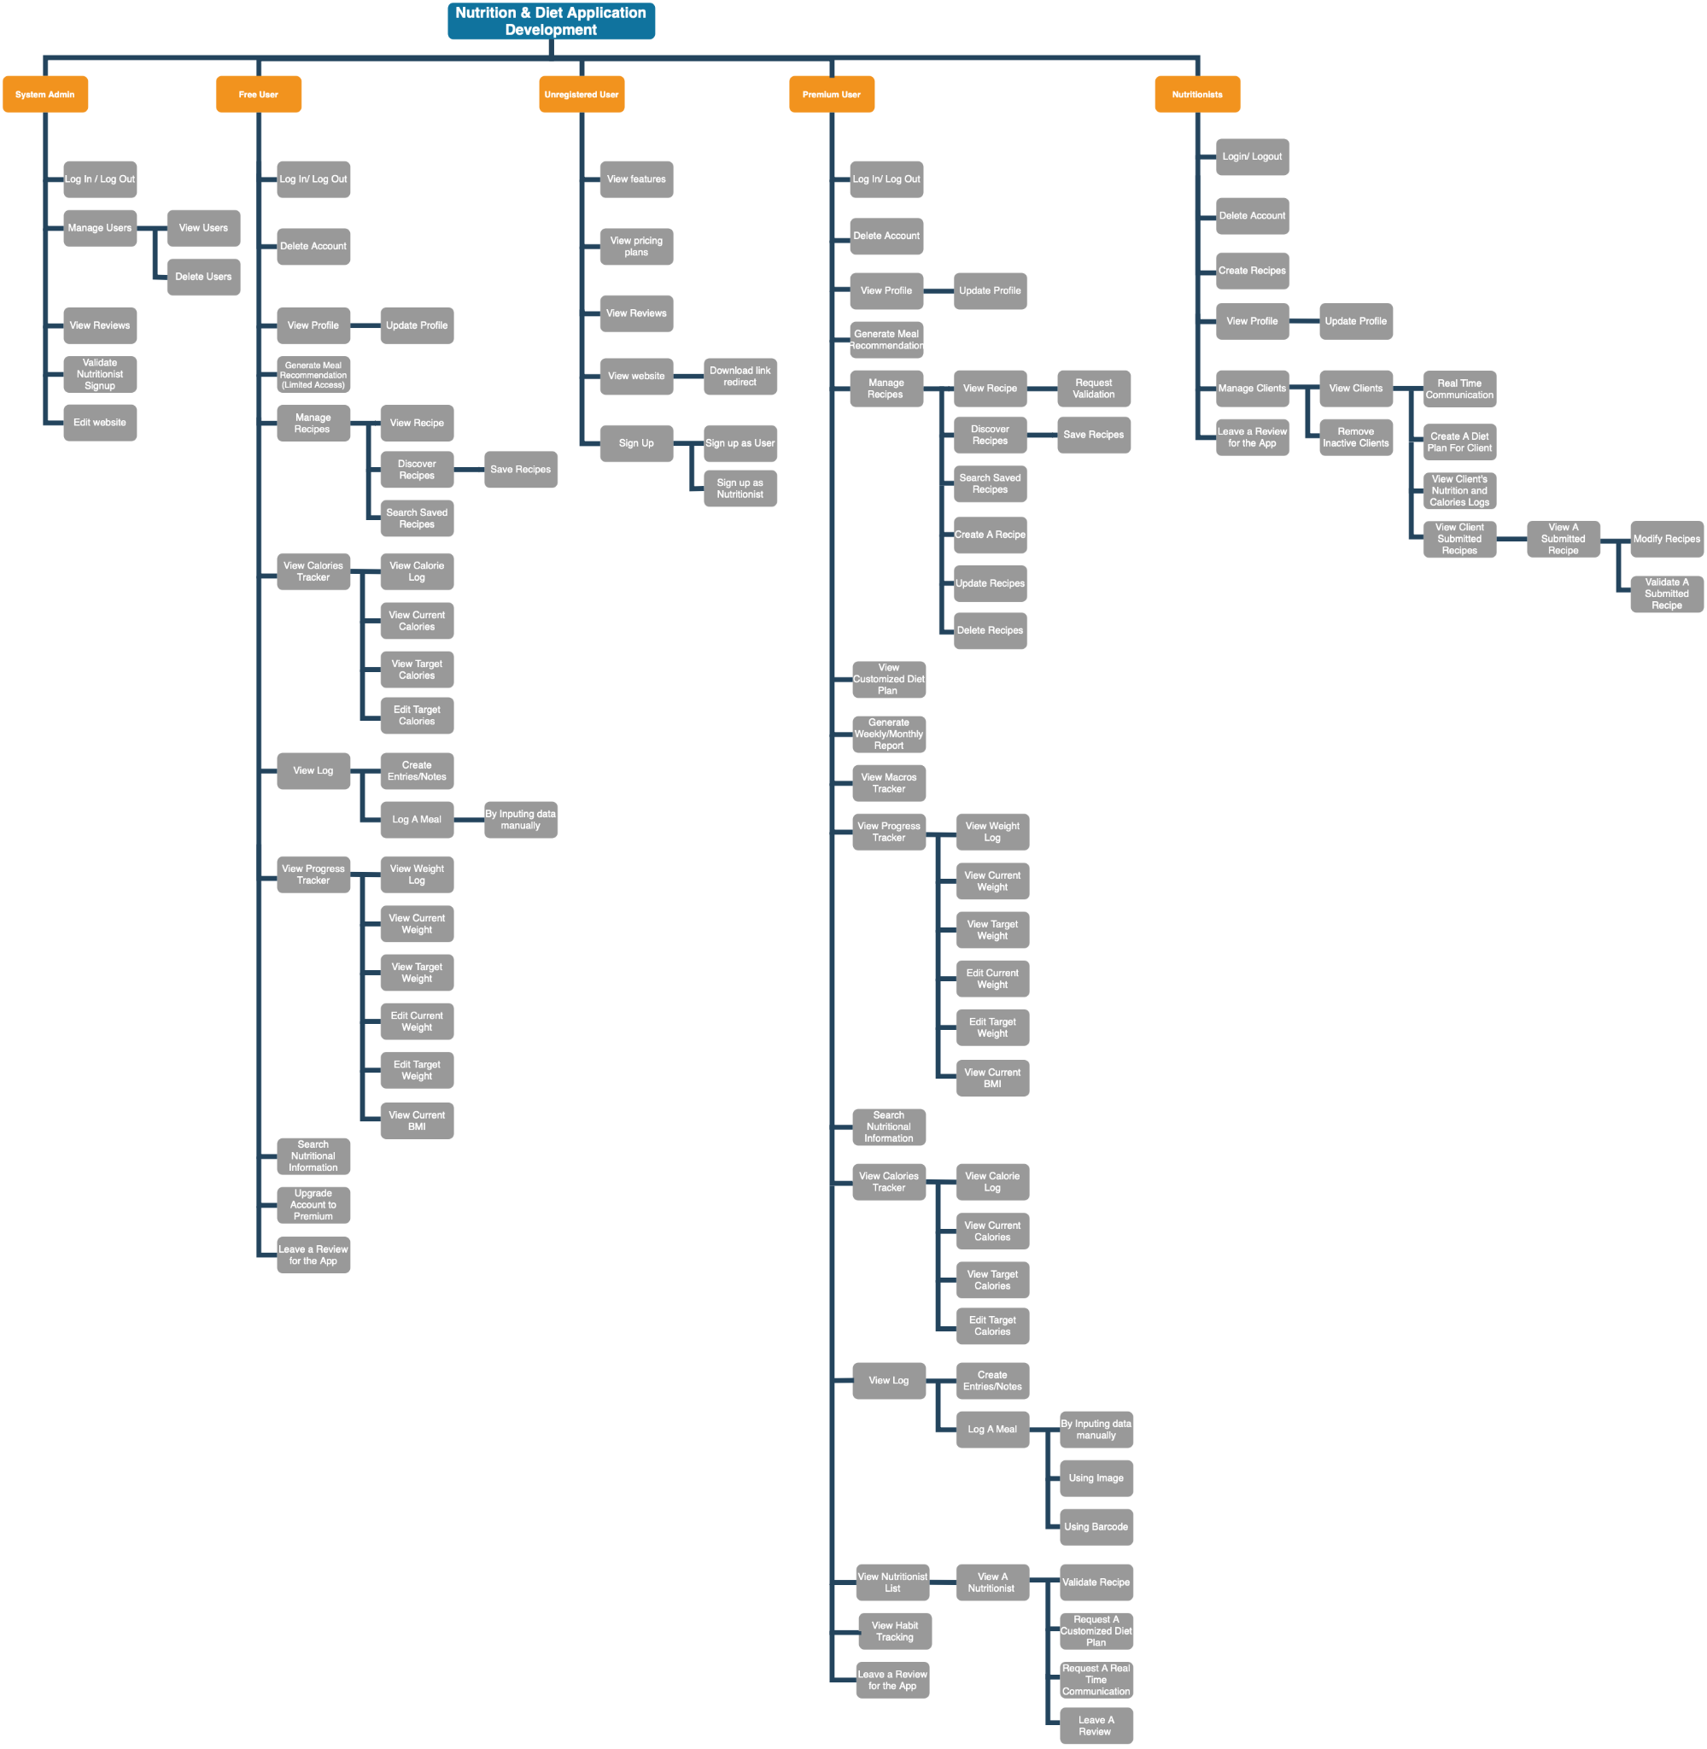

Unregistered User
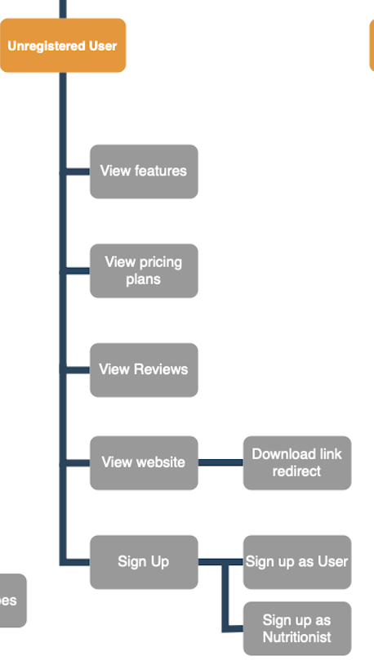

System Admin
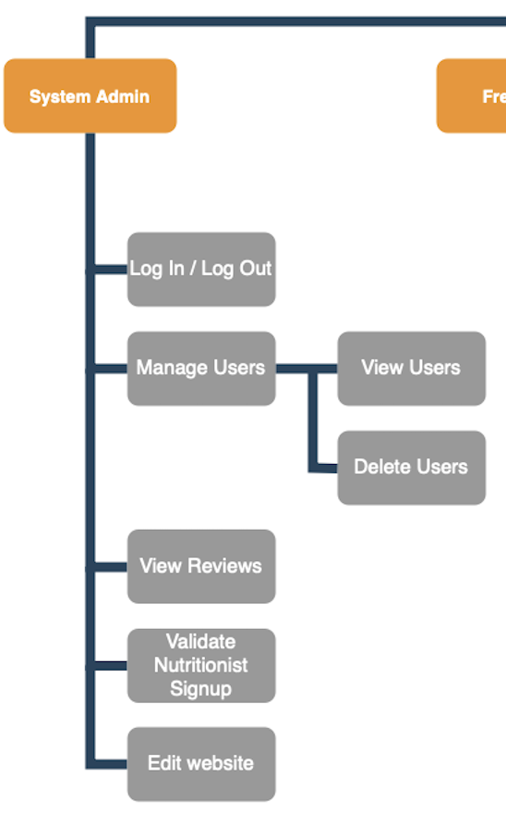

Free User
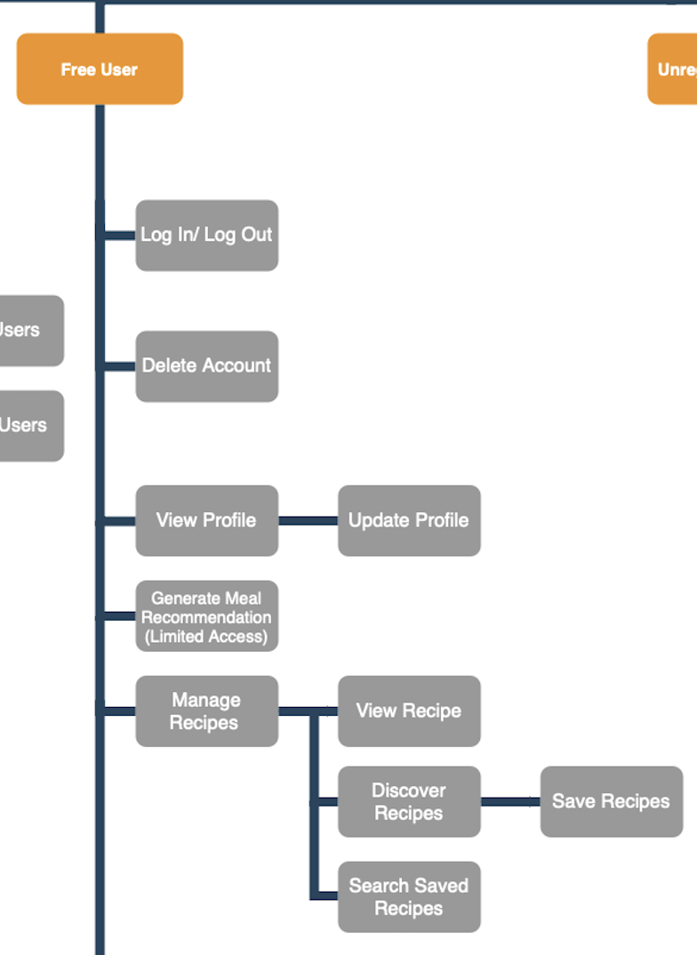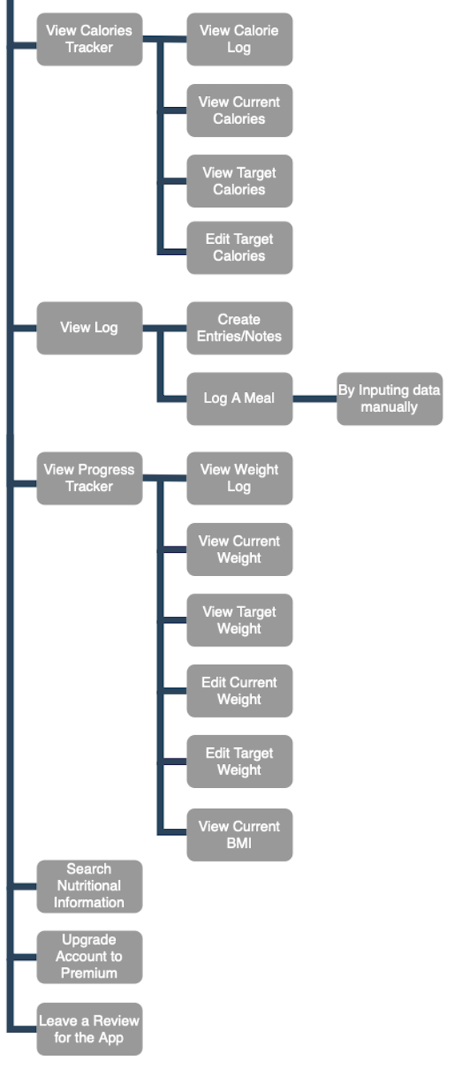

Premium User
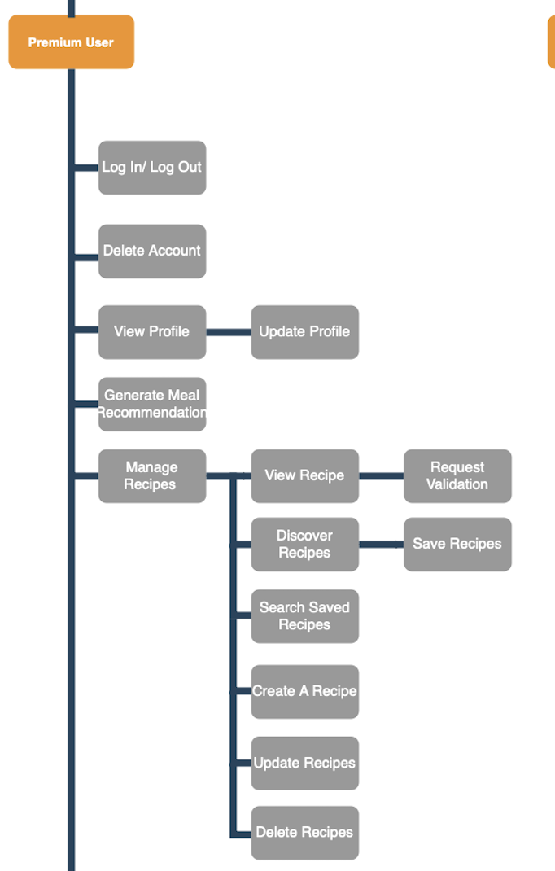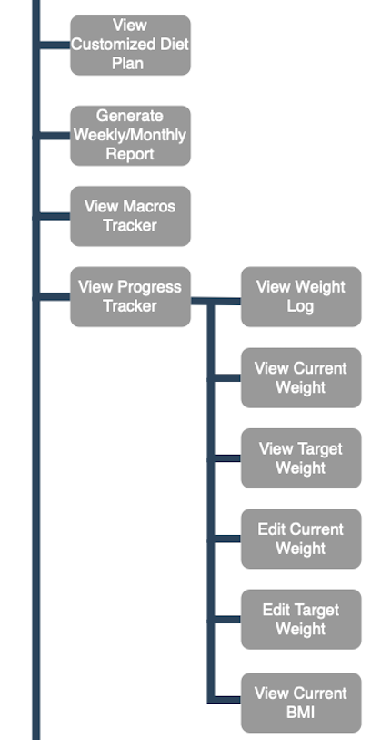

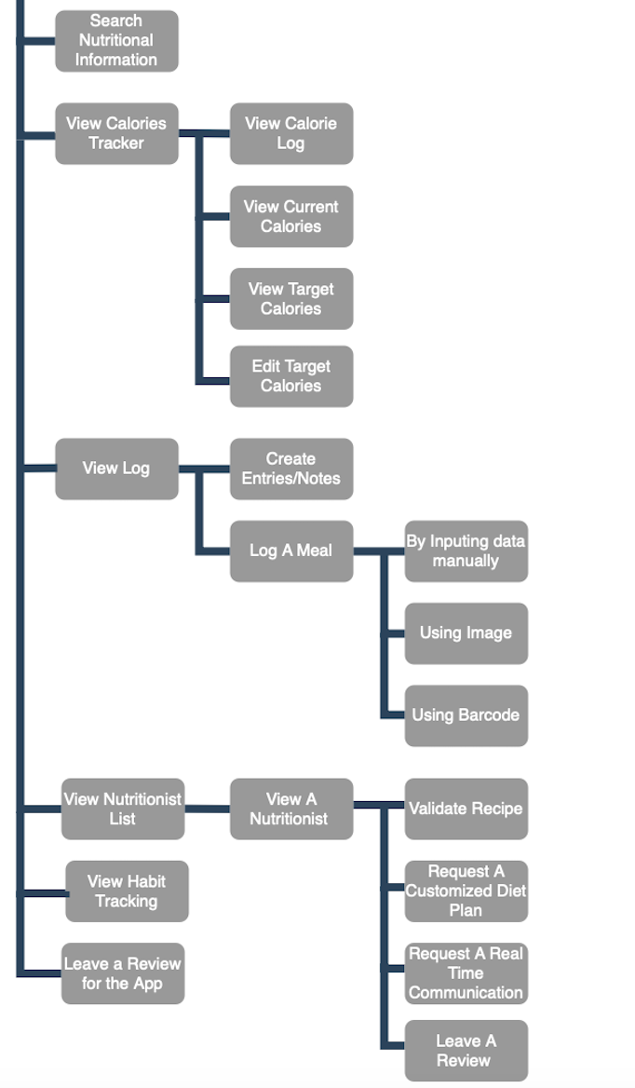

Nutritionist
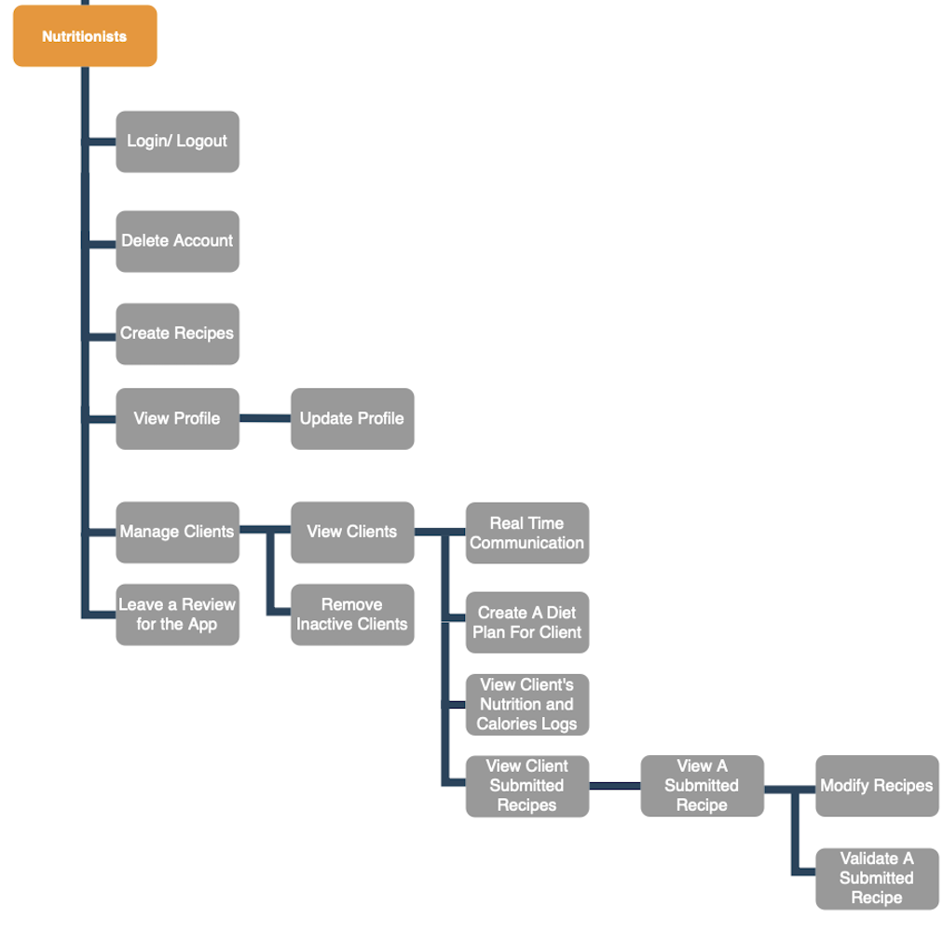

System Admin
FEATURE-1 | Log In / Log out
FEATURE-2 | Manage Users
FEATURE-2.1 | View Users
FEATURE-2.2 | Delete Users
FEATURE-2.3 | Search User
FEATURE-3 | View Reviews
FEATURE-4 | Validate Nutritionist Signup
FEATURE-5 | Edit Website

Unregistered User
FEATURE-1 | Visit Website
FEATURE-1.1 | Click download link
FEATURE-2 | View Pricing
FEATURE-3 | View Features
FEATURE-4 | View Reviews
FEATURE-5 | Sign up as user
FEATURE-5.1 | Sign up as nutritionist

Free User
FEATURE-1 | Log In / Log Out
FEATURE-2 | Delete Account
FEATURE-3 | View Profile
FEATURE-3.1 | Update Profile
FEATURE-4 | Generate Meal Recommendation
FEATURE-5 | Manage Recipes
FEATURE-5.1 | View Recipe
FEATURE-5.2 | Search Saved Recipe
FEATURE-5.3 | Discover Recipe
FEATURE-5.3.1 | Save Recipes
FEATURE-6 | View Calories Tracker
FEATURE-6.1 | View Calorie Log
FEATURE-6.2 | View Current Calories
FEATURE-6.3 | View Target Calories
FEATURE-6.4 | Edit Target Calories
FEATURE-7 | View Log
FEATURE-7.1 | Create Entries/Notes
FEATURE-7.2 | Log A Meal
FEATURE-7.2.1 | Via manual data input
FEATURE-8 | View Progress Tracker
FEATURE-8.1 | View Weight Log
FEATURE-8.2 | View Current Weight
FEATURE-8.3 | Edit Current Weight
FEATURE-8.4 | Edit Target Weight
FEATURE-8.5 | View Current BMI
FEATURE-9 | Search Nutritional Information
FEATURE-10 | Upgrade Account To Premium
FEATURE-11 | Leave A Review For The Application

Premium User
FEATURE-1 | Log In / Log Out
FEATURE-2 | Delete Account
FEATURE-3 | View Profile
FEATURE-3.1 | Update Profile
FEATURE-4 | Generate Meal Recommendation
FEATURE-5 | Manage Recipes
FEATURE-5.1 | View Recipe
FEATURE-5.1.1 | Request Validation
FEATURE-5.2 | Search Saved Recipe
FEATURE-5.3 | Discover Recipe
FEATURE-5.3.1 | Save Recipes
FEATURE-5.4 | Create a Recipe
FEATURE-5.5 | Update Recipes
FEATURE-5.6 | Delete Recipes
FEATURE-6 | View Customized Diet Plan
FEATURE-7 | Generate Weekly/Monthly Report
FEATURE-8 | View Macros Tracker
FEATURE-9 | View Progress Tracker
FEATURE-9.1 | View Weight Log
FEATURE-9.2 | View Current Weight
FEATURE-9.3 | Edit Current Weight
FEATURE-9.4 | Edit Target Weight
FEATURE-9.5 | View Current BMI
FEATURE-10 | Search Nutritional Information
FEATURE-11 | View Calories Tracker
FEATURE-11.1 | View Calorie Log
FEATURE-11.2 | View Current Calories
FEATURE-11.3 | View Target Calories
FEATURE-11.4 | Edit Target Calories
FEATURE-12 | View Log
FEATURE-12.1 | Create Entries/Notes
FEATURE-12.2 | Log A Meal
FEATURE-12.2.1 | Via manual data input
FEATURE-12.2.2 | Via image
FEATURE-12.2.3 | Via barcode
FEATURE-13 | View Nutritionist List
FEATURE-13.1 | View A Nutritionist
FEATURE-13.1.1 | Validate Recipe
FEATURE-13.1.2 | Request A Customized Diet Plan
FEATURE-13.1.3 | Request Real Time Communication
FEATURE-13.1.4 | Leave A Review
FEATURE-14 | View Habit Tracking
FEATURE-15 | Leave A Review For The Application

Nutritionist
FEATURE-1 | Log In / Log Out
FEATURE-2 | Delete Account
FEATURE-3 | Create Recipes
FEATURE-4 | View Profile
FEATURE-4.1 | Update Profile
FEATURE-5 | Manage Clients
FEATURE-5.1 | View Clients
FEATURE-5.1.1 | Real Time Communication With Client
FEATURE-5.1.2 | Create A Diet Plan For Client
FEATURE-5.1.3 | View Client’s Nutrition And Calories Logs
FEATURE-5.1.4 | View Client Submitted Recipes
FEATURE-5.1.4.1 | View A Submitted Recipe
FEATURE-5.1.4.1.1 | Modify Recipes
FEATURE-5.1.4.1.2 | Validate A Submitted Recipe
FEATURE-5.2 | Remove Inactive Clients
FEATURE-6 | Leave A Review For The Application

2.3 User Classes and Characteristics
Users | Characteristics
Unregistered User | The user will be able to visit the project website to look at the features and pricing. The user can also download the application and see the features and pricing on a quick slideshow before the login/signup option. The user can also view reviews of the application and download link on the website. Lastly, the User will be able to sign up either as a free user or a nutritionist.
Free User | The user can log in and log out of the application. After logging in, they can choose to delete their account if they want. They can also view and update their profile.  The user can generate meal recommendations for themselves and look at a tab to manage their recipes where they can choose to view a recipe, discover recipes, save recipes and search for their saved recipes.  The user can also view their calories tracker which shows their calories log, current calories and target calories. The user can also edit their target calories.  The user can also view their log and create entries/notes in it. From there, they can choose to log a meal by inputting the data manually.  The user can view their progress tracker, which shows their weight log, current BMI, current weight and target weight. They also have the option to edit current weight and target weight.  They then can search for nutritional information on a particular food item, have the option to upgrade their account to premium and leave a review for the application
Premium User | The user can log in and log out of the application. After logging in, they can choose to delete their account if they want. They can also view and update their profile.  The user can generate meal recommendations for themselves and look at a tab to manage their recipes where they can choose to view a recipe, discover recipes, save recipes and search for their saved recipes. In addition, the user can also create a recipe, update recipes and delete recipes.  The user can view a customized diet plan if they have one, generate a weekly/monthly report and view macros tracker.  The user can view their progress tracker, which shows their weight log, current BMI, current weight and target weight. They also have the option to edit current weight and target weight.  The user can then search for nutritional information on a particular food item to find out more about it.  The user can also view their calories tracker which shows their calories log, current calories and target calories. The user can also edit their target calories.  The user can also view their log and create entries/notes in it. From there, they can choose to log a meal by inputting the data manually, using an image powered by AI and using a barcode search.  The user will be able to view a list of nutritionists which they can then choose to view as a single nutritionist. They can then choose to ask the nutritionist to validate their recipe, request a customized diet plan from them, request real time communication with them and leave a review on them.  Lastly, the user can view habits tracking and leave a review for the application.
Nutritionist | The nutritionist can log in and out of the application and choose to delete their account if they want. They can create recipes for the platform. They can manage their clients and view their clients, which they can then have real time communication with their client, create a diet plan for them, view their nutrition and calories logs, view their submitted recipes in order to modify it and validate it. They can remove inactive clients and leave a review for the application.
System Admin | A system admin can log in and out of the admin web portal, manage current users, view a user and delete a user. They can also view the reviews on the application and validate signups from nutritionists. Lastly, they can edit the website.

2.4 Operating Environment

Operating Environment 1 | The mobile application requires a working android or apple operating system that is compatible with javascript, react.js, node.js.
Operating Environment 2 | The mobile application requires access to internet connection
Operating Environment 3 | All personal data should be encrypted

2.5 Design and Implementation Constraints
Constraint 1 | UI should be created through React Native, javascript, and Node.js.
Constraint 2 | Data should be stored in Firebase and MongoDB.
Constraint 3 | The mobile application requires access to stable internet connection.
Constraint 4 | For the best experience, we recommend keeping the mobile OS updated to the latest version.
Constraint 5 | A secure database will be used to store sensitive data regarding users, and nutritionists.

2.6 User Documentation

Upon entering the mobile application, users will be required to enter their login credentials. If they do not have an account, they can choose to sign up either as a user or nutritionist. If they choose to sign up as a user, they need to verify via email. If they choose to sign up as a nutritionist, they will need to go through additional verification done by the system administrator.
After logging in, the user will have access to their daily calories logs, options to log meals, view their current calories, target calories and editing of their goals. They also have an option to view nutritionists and to look at recipes which allows them to view recipes, discover and save recipes.f they are a free user, they have the option to upgrade to a premium user at a cost which upgrades them by giving them features such as creating recipes, updating recipes, getting their recipes validated, report generation, customized diet plans and nutritionist access as well as AI food recognition.

2.7 Assumption and Dependencies

Assumption 1 | For the best experience, we recommend keeping the mobile OS updated to the latest version.
Assumption 2 | The mobile application requires access to stable internet connection.
Assumption 3 | The mobile application assumes your phone is capable of running the application.
Assumption 4 | The mobile application assumes that its users enter genuine and legitimate information, as the application will be tailored to the user's input.

3. System Features

3.1 Use Case Diagram - Unregistered User

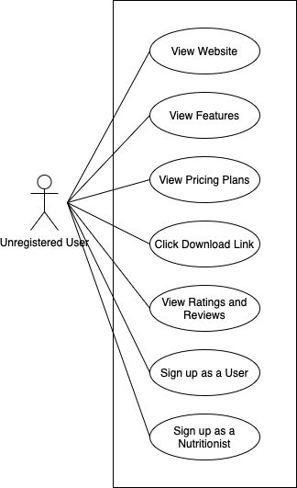

3.1.1 User Stories - Unregistered User
- As an unregistered user, I want to visit a website that shows me more information about the application so I can be well-informed.
- As an unregistered user, I want to see what features the application has so I can decide if I want to use it.
- As an unregistered user, I want to see the pricing plans of the subscription before I decide to pay for the premium features.
- As an unregistered user, I want to click on a download link to be redirected to the respective platform corresponding to the OS of my device.
- As an unregistered user, I want to be able to view reviews before deciding on downloading the app.
- As an unregistered user, I want to sign up so I can start using the app.
- As an unregistered user, I want to be able to sign up as a nutritionist if I have the qualifications for it.

3.1.2 Use Case Description - Unregistered User

Name: View Website (Unregistered User) | ID: U01
Stakeholders and goals: Unregistered users can view our website
Description: Unregistered users should be able to view the landing page of the website
Actors: Unregistered User
Trigger: This event will be triggered when the user enters the site
Normal Flow:
- The unregistered user will enter the website
- The website will show the landing page with all the necessary details
Sub-Flows: None
Alternative/Exceptional Flows:

Name: View Features of the App | ID: U02
Stakeholders and goals: Unregistered users can understand the app's functionalities
Description: Displays a list of app features, including descriptions and screenshots
Actors: Unregistered User
Trigger: The user navigates to the features section of the website.
Normal Flow:
- The unregistered user clicks on the "Features" section.
- The website displays a list of features, each with a brief description and an accompanying screenshot.
Sub-Flows: None
Alternative/Exceptional Flows:

Name: View Pricing plans of The Subscription | ID: U03
Stakeholders and goals: Unregistered users can evaluate subscription options before committing.
Description: Displays pricing tiers and features included in each plan
Actors: Unregistered User
Trigger: The user navigates to the "Pricing" section of the website.
Normal Flow:
- The unregistered user clicks on the "Pricing" section.
- The website displays the available subscription plans and their associated features.
Sub-Flows: None
Alternative/Exceptional Flows:

Name: Download the Application | ID: U04
Stakeholders and goals: Unregistered users can easily download the app for their device.
Description: Provides links to download the app for iOS and Android platforms
Actors: Unregistered User
Trigger: The user clicks the "Download" button on the website.
Normal Flow:
- The unregistered user clicks the "Download" button.
- The website redirects the user to the appropriate app store based on their device's operating system.
Sub-Flows: None
Alternative/Exceptional Flows:

Name: View User Reviews | ID: U05
Stakeholders and goals: Unregistered users can read reviews to evaluate the app
Description: Displays user reviews and ratings for the app
Actors: Unregistered User
Trigger: The user navigates to the "Reviews" section of the website.
Normal Flow:
- The unregistered user clicks on the "Reviews" section.
- The website displays user reviews, including ratings, feedback, and timestamps.
Sub-Flows: None
Alternative/Exceptional Flows:

Name: Sign Up As A Regular User (Unregistered User) | ID: U06
Stakeholders and goals: Unregistered users can successfully sign up.
Description: An unregistered user should be able to sign up for an account
Actors: Unregistered User
Trigger: The user clicks the "Sign Up" button on the website or app
Normal Flow:
- The unregistered user will click on the signup button
- The system shows the signup form
- Unregistered users will key in the details and click submit
- The system will validate the form
- The system will show the new user has been created
Sub-Flows: None
Alternative/Exceptional Flows:
4a. The system is unable to validate the form
5a. New User is not created.

Name: Sign Up As A Nutritionist (Unregistered User) | ID: U07
Stakeholders and goals: Unregistered users can sign up as nutritionist.
Description: Allows users with relevant qualifications to sign up as nutritionists.
Actors: Unregistered User
Trigger: The user selects the "Sign Up as a Nutritionist" option.
Normal Flow:
- The unregistered user clicks on "Sign Up as a Nutritionist."
- The app displays a form for entering personal details, qualifications, and certifications.
- The user completes the form and submits the application.
- The app notifies the user that their application is under review.
Sub-Flows: None
Alternative/Exceptional Flows:
1a. If required fields are incomplete, the app highlights the missing fields and prompts the user to complete them.

3.2 Use Case Diagram - Free User
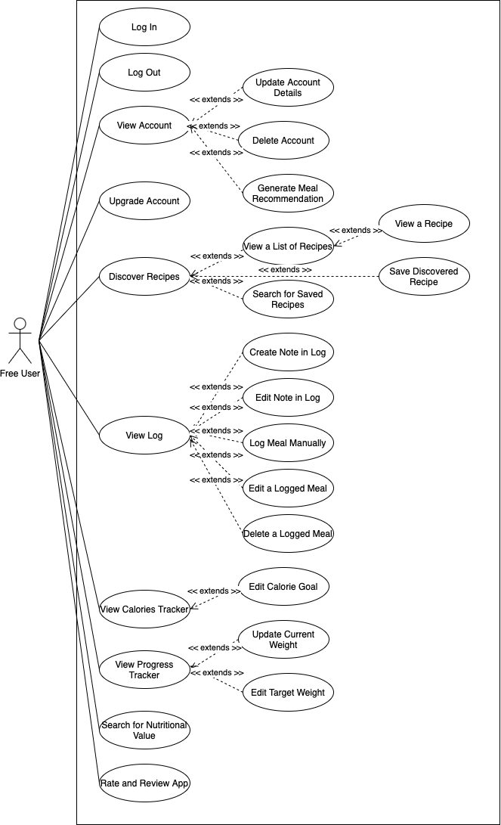

3.2 User Stories- Free User
- As a user, I want to log in so I can access the app.
- As a user, I want to log out so I can make sure that my current session has ended properly.
- As a user, I want to delete my account so I can stop using the app.
- As a user, I want to view my account details so I can see if my details are up to date.
- As a user, I want to update my account details so I can keep my details up to date.
- As a user, I want to upgrade my account to a premium user so that I can use the premium functions.
- As a user, I want to view a list of recipes so I can quickly access and manage my saved or created recipes.
- As a user, I want to view a recipe so I can look at the recipe in detail.
- As a user, I want to discover recipes so I can explore new meal ideas that align with my tastes and dietary needs.
- As a user, I want to generate meal recommendations so I can find new meals to eat.
- As a user, I want to save discovered recipes so I can easily access them later and try them.
- As a user, I want to search for saved recipes so I can find recipes easily.
- As a user, I want to view a log of my meals, so I can see my past meals.
- As a user, I want to create a note in my log so I can note down my thoughts for that day.
- As a user, I want to edit notes in my log so I can correct mistakes or add new details.
- As a user, I want to log my meals manually so I can track my caloric intake.
- As a user, I want to edit a logged meal to correct any misinput.
- As a user, I want to delete a logged meal if I accidentally logged a meal.
- As a user, I want to view my calorie tracker so I can know my current, target calories and calories logs.
- As a user, I want to edit my calorie goal so that I can ensure my daily target aligns with my fitness and health objectives.
- As a user, I want to view my progress tracker so I can know my current, target weight
- As a user, I want to update my current weight so I can track my progress accurately.
- As a user, I want to edit my target weight so I can adjust my goals as needed.
- As a user, I want to search for the nutritional values of any food item so I can find out more about it.
- As a user, I want to provide ratings and reviews for the app to assist others in evaluating its suitability before downloading.

3.2 Use Case Descriptions- Free User

Name: Log In | ID: F01
Stakeholders and goals: User can successfully login into the app
Description: A user needs to login before using the system
Actors: Free and Premium User
Trigger: The user clicks on the Login button.
Normal Flow:
- The user will click on the login button
- The system shows the login form
- The user will enter login details
- The system will validate the details
- The user will be logged in
Sub-Flows: None
Alternative/Exceptional Flows:
1a. If the username/password is wrong or unfilled, the message ‘Invalid username/password’ is displayed.

Name: Log Out | ID: F02
Stakeholders and goals: User can successfully logout of the app
Description: A user needs to logout after using the system
Actors: Free and Premium User
Trigger: The user clicks on the Log out button
Normal Flow:
- The user will already be logged in
- The user will click on the logout button
- The user will be logged out
Sub-Flows: None
Alternative/Exceptional Flows: None

Name: Delete Account | ID: F03
Stakeholders and goals: User can delete/deactivate their account
Description: The user will be able to delete their account if necessary
Actors: Free and Premium User
Trigger: The user clicks on the deactivate button
Normal Flow:
- The user will be logged in
- The user will click on the deactivate button
- The account will be deactivated and the user will be logged out
Sub-Flows: None
Alternative/Exceptional Flows: None

Name: View Account/Profile Details | ID: F04
Stakeholders and goals: User will be able to view account details
Description: The user will be able to view account name, email, age, weight
Actors: Free and Premium User
Trigger: The user clicks on the view account details button
Normal Flow:
- User will already be logged in
- User will click on the view account/Profile details button
- System will show the user account/Profile details
Sub-Flows: None
Alternative/Exceptional Flows: None

Name: Update Account/Profile Details | ID: F05
Stakeholders and goals: User will be able to update/change account details
Description: The user will be able to update/change account name, email, age, weight
Actors: Free and Premium User
Trigger: The user clicks on the update account details button
Normal Flow:
- User will already be logged in
- User will click on the view account/profile details button
- User will click on the update account/profile button
Sub-Flows: None
Alternative/Exceptional Flows: None

Name: Upgrade Account to Premium User (Free user) | ID: F06
Stakeholders and goals: User will be able to upgrade to premium
Description: User will be able to upgrade to premium for additional features
Actors: Free User
Trigger: The user clicks on the upgrade account button
Normal Flow:
- The user will be logged in as a free user
- User clicks on the upgrade account button
- System will show details and features that comes with premium
- System will prompt payment method
Sub-Flows: None
Alternative/Exceptional Flows: None

Name: View A List of Recipes | ID: F07
Stakeholders and goals: The user will be able to view a list of recipes
Description: User will be able to manage a list of recipes
Actors: Free and Premium User
Trigger: The user clicks on the manage recipes button
Normal Flow:
- The user will be logged in
- The user will click on the manage recipes button
- The system will show view recipe, discover recipe and search saved recipe
Sub-Flows: None
Alternative/Exceptional Flows: None

Name: View A Recipe | ID: F08
Stakeholders and goals: The user will be able to view a recipe
Description: The user can view the details of a recipe from the manage recipe
Actors: Free and Premium User
Trigger: User clicks on the view a recipe button
Normal Flow:
- User clicks on manage recipe button
- User then clicks on view a recipe button
- System shows the details of a recipe
Sub-Flows: None
Alternative/Exceptional Flows: None

Name: Discover Recipes | ID: F09
Stakeholders and goals: User wants to find new recipe
Description: User will be able to discover new recipes from this tab
Actors: Free and Premium User
Trigger: User clicks on discover recipes button
Normal Flow:
- The user clicks on manage recipes
- The user then clicks on discover recipes
- System shows new recipes for the user
Sub-Flows: None
Alternative/Exceptional Flows: None

Name: Generate Meal Recommendations | ID: F10
Stakeholders and goals: User wants to have meal recommendations
Description: The user will be able to generate new meal recommendations
Actors: Free and Premium User
Trigger: The user clicks on the generate new meal recommendation button
Normal Flow:
- User clicks on manage recipes
- User then clicks on discover recipes
- User then clicks on generate meal recommendation
- System shows the generated meal recommendation for the user
Sub-Flows: None
Alternative/Exceptional Flows: None

Name: Save Discovered Recipes | ID: F11
Stakeholders and goals: User wants to keep discovered recipes
Description: User will be able to save recipes they found from the discover recipe page
Actors: Free and Premium User
Trigger: The user clicks on the save recipe button
Normal Flow:
- User will be in discover recipes page
- User will click on save recipe button
- System will save the recipe for the user to find easily
Sub-Flows: None
Alternative/Exceptional Flows: None

Name: Search for Saved Recipes | ID: F12
Stakeholders and goals: User wants to search through recipes that are saved
Description: User will be able to search within list of saved recipes
Actors: Free and Premium User
Trigger: The user clicks on the search bar in saved recipes
Normal Flow:
- User clicks on saved recipes
- User clicks on search bar and types a search term
- System shows saved recipes that match the search term
Sub-Flows: None
Alternative/Exceptional Flows:
2a. If no recipes are found, system shows message ‘No recipes found’.

Name: View Log/Diary | ID: F13
Stakeholders and goals: User wants to view log/diary entries that they have inputted in order to keep track of their progress
Description: User will be able to view a log of their diary
Actors: Free and Premium User
Trigger:
Normal Flow:
- User clicks on log/diary tab
- System displays the user's log/diary entries
Sub-Flows: None
Alternative/Exceptional Flows:
1a. If there are no entries, the system displays a message indicating that no logs are available.

Name: Create A Note In My Log | ID: F14
Stakeholders and goals: User wants to create a note in their log to track progress
Description: User will be able to add a new note to their log
Actors: Free and Premium User
Trigger: The user clicks on the "Add Note" button
Normal Flow:
- User clicks on log/diary tab
- User clicks on "Add Note" button
- System displays a text input field
- User enters note details and clicks save
- System saves the note and displays it in the log.
Sub-Flows: None
Alternative/Exceptional Flows:
4a. If user does not enter any text and tries to save, system displays an error message.

Name: Edit Notes In My Log | ID: F15
Stakeholders and goals: User wants to modify existing notes in their log
Description: User will be able to edit notes they have previously saved
Actors: Free and Premium User
Trigger: The user clicks on an existing note
Normal Flow:
- User clicks on log/diary tab
- User selects a note to edit
- System displays the note in an editable format
- User makes modifications and saves
- System updates the note
Sub-Flows: None
Alternative/Exceptional Flows: None

Name: Log Meal Manually | ID: F16
Stakeholders and goals: User wants to manually log meals for tracking dietary intake
Description: User will be able to manually log meal details
Actors: Free and Premium User
Trigger: The user clicks on "Log Meal" button
Normal Flow:
- User clicks on "Log Meal" button
- System displays a meal logging form
- User enters meal details (Name, Ingredients, Ingredient weight in grams) and saves
- System saves the meal entry
Sub-Flows: None
Alternative/Exceptional Flows:
4a. If user submitted empty values, system displays an error message.

Name: Edit Logged Meal | ID: F17
Stakeholders and goals: User wants to edit logged meals to correct misinput
Description: User will be able to edit logged meal details
Actors: Free and Premium User
Trigger: The user clicks on "Edit meal" button
Normal Flow:
- User clicks on "Edit meal" button
- System displays a form
- User enters meal details (Name, Ingredients, Ingredient weight in grams) and saves
- System saves the meal
Sub-Flows: None
Alternative/Exceptional Flows:
4a. If user submitted invalid values, the system displays an error message.

Name: Delete logged meal | ID: F18
Stakeholders and goals: User wants to delete a logged meal
Description: User will be able to manually log meal details
Actors: Free and Premium User
Trigger: The user clicks on "Log Meal" button
Normal Flow:
- User clicks on "Log Meal" button
- System displays a meal logging form
- User enters meal details (Name, Ingredients, Ingredient weight in grams) and saves
- System saves the meal entry
Sub-Flows: None
Alternative/Exceptional Flows:
None

Name: View Calorie Tracker | ID: F19
Stakeholders and goals: User wants to monitor calorie intake
Description: User will be able to view their calorie tracking summary
Actors: Free and Premium User
Trigger: The user clicks on the "Calorie Tracker" tab
Normal Flow:
- User clicks on "Calorie Tracker" tab
- System displays the user's calorie intake and remaining calories for the day, and calories over time graphs.
Sub-Flows: None
Alternative/Exceptional Flows: None

Name: Edit Calorie Goal | ID: F20
Stakeholders and goals: User wants to modify their daily calorie goal
Description: User will be able to change their daily calorie goal
Actors: Free and Premium User
Trigger: The user clicks on "Edit Daily Calorie Goal" button
Normal Flow:
- User clicks on "Edit Daily Calorie Goal" button
- System displays a text box to modify the daily calorie goal
- User enters a new daily calorie goal and saves
- System updates and displays the new daily goal
Sub-Flows: None
Alternative/Exceptional Flows:
3a. If user enters an invalid number, system displays an error message.

Name: View Progress Tracker | ID: F21
Stakeholders and goals: User wants to view their progress over time
Description: User will be able to view charts and statistics of their progress
Actors: Free and Premium User
Trigger: The user clicks on "Progress Tracker" tab
Normal Flow:
- User clicks on "Progress Tracker" tab
- System displays graphical representations of progress based on user data
Sub-Flows: None
Alternative/Exceptional Flows: None

Name: Update Current Weight | ID: F22
Stakeholders and goals: The user updates their weight to ensure their progress and nutritional calculations are accurate.
Description: The user updates their current weight in the app to maintain accurate tracking of their progress and adjust recommendations if applicable.
Actors: Free and Premium User
Trigger: The user selects the "Update Weight" option in their profile or progress dashboard.
Normal Flow:
- The user navigates to the profile or progress section.
- The user selects the "Update Current Weight" option.
- The system displays a form to input the new weight.
- The user enters their new weight and submits it.
- The system saves the updated weight and recalculates progress and recommendations.
- The system displays a confirmation message and updated progress details.
Sub-Flows: None
Alternative/Exceptional Flows:
4a. If the user enters an invalid weight (e.g., non-numeric or negative), the system displays an error and prompts for correction.

Name: Edit Target Weight | ID: F23
Stakeholders and goals: The user edits their target weight to align their goals with changes in their plans or progress.
Description: The user updates their target weight to adjust their goals and ensure personalized recommendations are accurate.
Actors: Free and Premium User
Trigger: The user selects the "Edit Target Weight" option in their profile or progress Tracker section
Normal Flow:
- The user navigates to the profile or progress section.
- The user selects the "Edit Target Weight" option.
- The system displays a text box to input the new target weight.
- The user enters their new target weight and submits.
- The system saves the updated target weight and recalculates recommendations or progress projections.
- The system displays a confirmation message and updates the target weight in the user’s goals.
Sub-Flows: None
Alternative/Exceptional Flows:
4a. If the user enters an invalid weight (e.g., non-numeric or negative), the system displays an error and prompts for correction.

Name: Search Nutritional Values of any food | ID: F24
Stakeholders and goals: Users want to search for nutritional values to make informed dietary decisions.
Description: Free and Premium users can search for detailed nutritional values of various foods.
Actors: Free and Premium User
Trigger: The user selects the "Search Food" option from the system menu.
Normal Flow:

- The user selects the "Search Food" option.
- The system displays a search bar for the user to enter the name of the food.
- The user inputs a food item name and submits the search.
- The system retrieves the nutritional data.
- The system displays the nutritional values of the food, including calories, macronutrients, and micronutrients.
Sub-Flows: None
Alternative/Exceptional Flows:
3a. If the user inputs an invalid or incomplete food name, the system suggests possible matches.
3b. If the food item is not found, the system displays error message.

Name: Rate and Review For The Application | ID: F25
Stakeholders and goals: Users want to share their feedback to improve the application and help others evaluate it.
Description: Nutritionists, Free Users, and Premium Users can leave a rating and review for the application.
Actors: Nutritionist, Free and Premium User
Trigger: The user selects the "Rate and Review" option in the app or store listing.
Normal Flow:
- The user selects the "Rate and Review" option from the app menu or app store.
- The system prompts the user to input a rating (e.g., 1-5 stars).
- The user writes a review in the provided text box.
- The user submits the rating and review.
- The system confirms that the review has been successfully submitted.
Sub-Flows: None
Alternative/Exceptional Flows:
2a. If the user skips the review, only the rating is submitted.
4a. If the review submission fails due to a network issue, the app notifies the user and allows retrying.

3.3 Use Case Diagram - Premium User
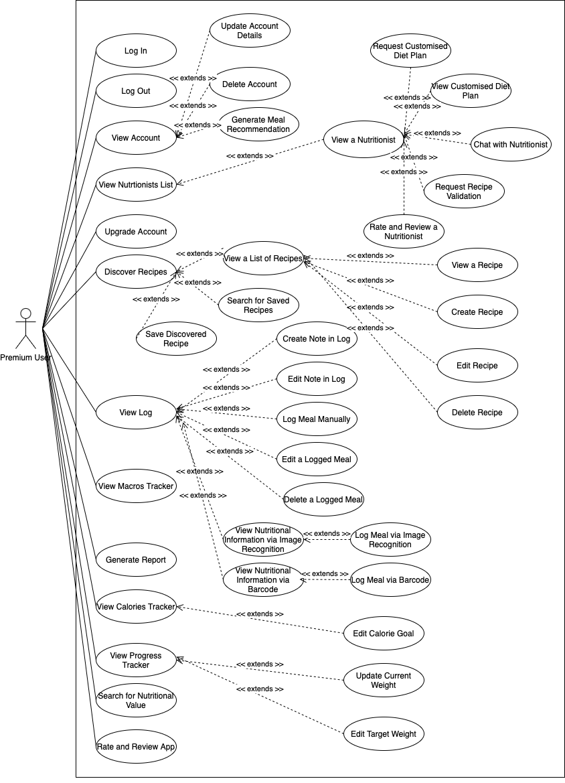

3.3 User Stories- Premium User
- As a user, I want to view my macros tracker so I can see what my macros consumed.
- As a user, I want to create a recipe so I can record my own recipe.
- As a user, I want to edit a recipe so I can change the details of a recipe.
- As a user, I want to delete a recipe so I can remove unwanted recipes.
- As a user, I want to use image recognition to analyze my meal so I can quickly and accurately identify its nutritional content without manual entry.
- As a user, I want to log a meal using image recognition so I can track my meals easily.
- As a user, I want to use a barcode scanner to quickly scan food items so I can retrieve accurate nutritional information without manual entry.
- As a user, I want to log a meal using a barcode scanner so I can track my meals easily.
- As a user, I want to see a list of nutritionists so I can choose my preferred nutritionist.
- As a user, I want to view a specific nutritionist so I can view more details about a nutritionist.
- As a user, I want to request validation of a recipe from a nutritionist so that I can have my recipe professionally validated.
- As a user, I want to request a customized diet plan from a nutritionist so that I can have a professionally validated diet plan.
- As a user, I want to view my customized diet plan so I can follow it effectively to meet my health and fitness goals.
- As a user, I want to chat with a nutritionist via text so I can consult them, or procure their service.
- As a user, I want to rate and review a nutritionist so I can provide numeral-based feedback and written feedback for the service provided.
- As a user, I want to generate reports on my caloric intake so I can view them.

3.3 Use Case Descriptions- Premium User

Name: View Macros Tracker | ID: P01
Stakeholders and goals: User wants to monitor macronutrient intake (carbohydrates, proteins, and fats)
Description: The user will be able to view their macronutrient tracking summary, including daily intake and trends over time.
Actors: Free and Premium User
Trigger: The user clicks on the "Macros Tracker" tab
Normal Flow:
- The user clicks on the "Macros Tracker" tab
- The system displays:
- The user's macronutrient intake (carbs, proteins, fats) for the day
- The remaining macronutrient allowance based on their goals
- Graphs showing macronutrient trends over time
Sub-Flows: None
Alternative/Exceptional Flows: None

Name: Create A Recipe | ID: P02
Stakeholders and goals: Premium Users can successfully create a recipe.
Description: Premium User can create a recipe by entering ingredients, instructions, and optional nutritional.
Actors: Premium User
Trigger: The premium user selects the "Create Recipe" option from the app menu.
Normal Flow:
- The user selects "Create Recipe" from the app menu.
- The app displays a form to input recipe details.
- The user enters the recipe name, ingredients, instructions, and optional nutritional information.
- The user submits the recipe.
- The app saves the recipe and confirms successful creation.
Sub-Flows: None
Alternative/Exceptional Flows:
3a. If required fields are missing, the app prompts the user to complete them.
4a. If the recipe submission fails, the app displays an error message and allows the user to retry.

Name: Edit A Recipe | ID: P03
Stakeholders and goals: Premium User can successfully edit an existing recipe.
Description: Premium User can modify details of an existing recipe.
Actors: Premium User
Trigger: The user selects the “Edit Recipe” option for a recipe.
Normal Flow:
The user selects a recipe to view from their saved list.
The user selects the “Edit Recipe” option.
The app displays the recipe details in an editable form.
The user updates the desired fields (e.g., ingredients, instructions, nutritional information).
The user saves the changes.
The app updates the recipe and confirms the changes.
Sub-Flows: None
Alternative/Exceptional Flows:
5a. If the save operation fails, the app displays an error message and allows the user to retry.

Name: Delete A Recipe | ID: P04
Stakeholders and goals: Premium User can successfully delete a recipe.
Description: Premium User can remove an existing recipe from their saved list.
Actors: Premium User
Trigger: The user selects the "Delete" option for a recipe.
Normal Flow:
- The user selects a recipe to delete from their saved list.
- The app displays a confirmation dialog.
- The user confirms the deletion.
- The app deletes the recipe and confirms successful removal.
Sub-Flows: None
Alternative/Exceptional Flows:
1a. If the delete operation fails, the app displays an error message and allows the user to retry.

Name: Use Image Recognition to Analyze Food | ID: P05
Stakeholders and goals: Premium User can analyze food items using image recognition.
Description: Premium User can upload an image of food to analyze nutritional content.
Actors: Premium User
Trigger: The user selects the "Analyze Meal" option and uploads an image.
Normal Flow:
- The user selects "Analyze Meal" from the app menu.
- The app prompts the user to upload or capture an image of the food.
- The user uploads the image.
- The app processes the image using image recognition.
- The app displays the analyzed nutritional content of the food.
Sub-Flows: None
Alternative/Exceptional Flows:
1a. If the image upload fails, the app notifies the user and allows retrying.
1b. If the image recognition process fails, the app displays an error message.

Name: Log A Meal After Image Recognition | ID: P06
Stakeholders and goals: Premium User logs a meal after analyzing its nutritional content.
Description: The user logs a meal after reviewing nutritional details provided by image recognition.
Actors: Premium User
Trigger: The user selects "Log Meal" after completing an analysis.
Normal Flow:
- The user selects "Log Meal" after reviewing the nutritional content.
- The app pre-fills the nutritional details based on the analysis.
- The user confirms or edits the details and logs the meal.
Sub-Flows: None
Alternative/Exceptional Flows: None

Name: Use Barcode Scanner to Scan Food | ID: P07
Stakeholders and goals: Premium User can identify food items nutritions by scanning barcodes.
Description: Premium User uses the barcode scanner to retrieve nutritional content from food items.
Actors: Premium User
Trigger: The user selects the "Scan Barcode" option.
Normal Flow:
- The user selects "Scan Barcode" from the app menu.
- The app activates the barcode scanner.
- The user scans the barcode on the food item.
- The app retrieves and displays the nutritional information of the scanned item.
Sub-Flows: None
Alternative/Exceptional Flows:
1a. If the barcode is invalid, the app notifies the user and allows retrying.
1b. If the database does not contain the barcode, the app displays an error message with an option to add a new item manually.

Name: Log A Meal After Scanning Barcode | ID: P08
Stakeholders and goals: Premium User logs a meal after scanning a food item's barcode.
Description: The user logs a meal using nutritional details retrieved from scanning a barcode.
Actors: Premium User
Trigger: The user selects "Log Meal" after scanning a barcode.
Normal Flow:
- The user selects "Log Meal" after viewing the nutritional content retrieved from the barcode.
- The app pre-fills the nutritional details based on the barcode data.
- The user confirms or edits the details and logs the meal.
Sub-Flows: None
Alternative/Exceptional Flows: None

Name: View A List of Nutritionists | ID: P09
Stakeholders and goals: Premium User can view a list of available nutritionist
Description: Premium User can browse a list of registered nutritionists.
Actors: Premium User
Trigger: The user selects the "View Nutritionists" option from the app menu.
Normal Flow:
- The user selects "View Nutritionists" from the app menu.
- The app retrieves the list of registered nutritionists.
- The app displays the list of nutritionists with basic details (e.g., name, specialization).
- The user can select a nutritionist for more details.
Sub-Flows: None
Alternative/Exceptional Flows:
1a. If no nutritionists are available, the app notifies the user.

Name: View A Specific Nutritionist | ID: P10
Stakeholders and goals: Premium User can view detailed information about a specific nutritionist.
Description: Premium User can view a nutritionist’s profile with detailed information.
Actors: Premium User
Trigger: The user selects a nutritionist from the list.
Normal Flow:
- The user selects a nutritionist from the displayed list.
- The app retrieves detailed information about the selected nutritionist.
- The app displays the nutritionist’s profile, including name, specialization, experience, and payment details.
Sub-Flows: None
Alternative/Exceptional Flows:
1a. If the nutritionist’s profile cannot be retrieved, the app notifies the user.

Name: Request Validation of A Recipe | ID: P11
Stakeholders and goals: Premium User can request a nutritionist to validate a recipe
Description: Premium User can submit a recipe for validation by a registered nutritionist.
Actors: Premium User
Trigger: The user selects the "Request Validation" option for a recipe.
Normal Flow:
- The user selects a recipe to request validation.
- The app displays the validation request form.
- The user submits the request with optional comments or questions.
- The app forwards the request to a registered nutritionist.
- The nutritionist reviews the recipe and provides feedback.
- The app notifies the user of the validation outcome.
Sub-Flows: None
Alternative/Exceptional Flows:
1a. If the request submission fails, the app notifies the user and allows retrying.
1b. If no nutritionists are available, the app notifies the user.

Name: Request A Customized Diet Plan | ID: P12
Stakeholders and goals: Premium User can request a tailored diet plan from a nutritionist
Description: Premium User can submit their dietary preferences, goals, and restrictions to receive a customized diet plan.
Actors: Premium User
Trigger: The user selects the "Request Diet Plan" option from the app menu.
Normal Flow:
- The user selects "Request Diet Plan" from the app menu.
- The app displays a form to input dietary preferences, goals (e.g., weight loss, muscle gain), and restrictions (e.g., allergies, vegan).
- The user completes the form and submits the request.
- The app forwards the request to a registered nutritionist.
- The nutritionist reviews the request and creates a customized diet plan.
- The app notifies the user when the diet plan is ready and allows them to view it.
Sub-Flows: None
Alternative/Exceptional Flows:
1a. If the request submission fails, the app notifies the user and allows retrying.
1b. If no nutritionists are available, the app notifies the user and suggests trying later.

Name: View My Customized Diet Plan | ID: P13
Stakeholders and goals: User - User can successfully view their customized diet plan.
Description: A user should be able to view their customized diet plan in the app.
Actors: User
Trigger: This event will be trigger when user click on the Customized Diet Plan tab
Normal Flow:
- The user will click on the Customized Diet Plan tab.
- System shows the Customized Diet Plan page
Sub-Flows: None
Alternative/Exceptional Flows: None

Name: Chat With A Nutritionist | ID: P14
Stakeholders and goals:
User: Consult a nutritionist for advice or services.
Nutritionist: Provide services to users through chat.
Description:
A user can initiate a text-based chat with a nutritionist to discuss dietary concerns or request services.
Actors: User
Trigger: The user selects the Chat with Nutritionist option from the nutritionist page.
Normal Flow:
- The user selects the Chat with Nutritionist option.
- The chat window opens, allowing the user and nutritionist to exchange messages.
Sub-Flows: None
Alternative/Exceptional Flows:

Name: Rate and Review A Nutritionist | ID: P15
Stakeholders and goals: User: Provide numeric and detailed written feedback for services received.
Description: A user can rate a nutritionist based on their service experience.
Actors: Free User, Premium User
Trigger: The user selects the Rate Nutritionist from the …
Normal Flow:
- The user selects the Rate Nutritionist option.
- The user selects a rating (1-5 stars)
- The user enters their feedback in the text box.
- The system records and displays the rating on the nutritionist’s profile
Sub-Flows: None
Alternative/Exceptional Flows:

Name: Generate Report On My Caloric Intake | ID: P16
Stakeholders and goals: Premium User can generate a detailed report of their daily, weekly, or monthly caloric intake
Description: Premium User can view a report summarizing their caloric intake over a selected time period, including charts and key metrics
Actors: Premium User
Trigger: The user selects the "Generate Report" option from the app menu.
Normal Flow:
- The user selects "Generate Report" from the app menu.
- The app prompts the user to select a time period (daily, weekly, or monthly).
- The user selects the desired time period.
- The app retrieves caloric intake data for the selected time period.
- The app generates a report with charts and key metrics (e.g., average intake, highest/lowest days).
- The app displays the report to the user.
Sub-Flows: None
Alternative/Exceptional Flows:
1a. If no data is available for the selected period, the app notifies the user.
1b. If report generation fails, the app displays an error message and allows the user to retry.

3.4 Use Case Diagram - Nutritionist
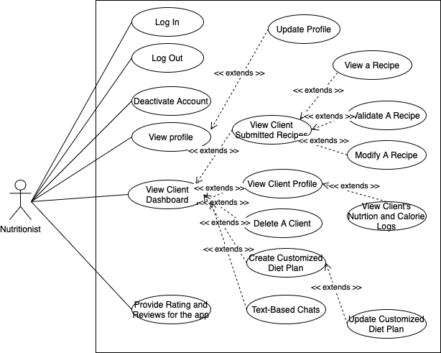

3.4 User Stories - Nutritionist
- As a nutritionist, I want to log in so I can access the app.
- As a nutritionist, I want to log out so I can make sure that my current session has ended properly.
- As a nutritionist, I want to deactivate my account so I can stop using the app.
- As a nutritionist, I want to view my profile so I can see if my details are up to date
- As a nutritionist, I want to update my profile so I can keep my details up to date.
- As a nutritionist, I want to view client-submitted recipes so I can make changes to them if needed.
- As a nutritionist, I want to view unvalidated recipes so I can see which recipes require my validation.
- As a nutritionist, I want to view a specific recipe so I can see the details of the recipes
- As a nutritionist, I want to modify a recipe so I can help the user to improve their recipe
- As a nutritionist, I want to validate recipes so that users can ensure the recipes meet their dietary needs and health goals.
- As a nutritionist, I want to view a dashboard of clients so I can manage and monitor their progress and requests efficiently.
- As a nutritionist, I want to view a client profile so I can access detailed information about their health history, preferences, and progress.
- As a nutritionist, I want to delete a client so I can remove inactive or outdated profiles from my system.
- As a nutritionist, I want to create a customized diet plan for my clients upon request so I can support their specific health goals and needs.
- As a nutritionist, I want to update a customized diet plan for my clients so I can adjust it based on their progress or changing needs.
- As a nutritionist, I want to engage in text-based chats with users so I can provide personalized advice, support their dietary goals, and manage multiple conversations efficiently.
- As a nutritionist, I want to view clients’ nutrition and calorie logs so I can ensure they are reaching their goals per day.
- As a nutritionist, I want to provide ratings and reviews for the app to assist others in evaluating its suitability before downloading.

3.4 Use Case Descriptions - Nutritionist

Name: Log In | ID: N01
Stakeholders and goals: Nutritionist: Nutritionist can successfully login into the app
Description: A nutritionist needs to login before using the system
Actors: Nutritionist
Trigger: The nutritionist click on the Log In button
Normal Flow:
- The nutritionist will click on the login button
- The system shows the login form
- The nutritionist will enter login details
- The system will validate the details
- The user will be logged in
Sub-Flows: None
Alternative/Exceptional Flows:
System is unable to authenticate user
Nutritionist is unable to log in to the system

Name: Log Out | ID: N02
Stakeholders and goals: Nutritionist can successfully log out from the system
Description: Nutritionist wants to log out from the system
Actors: Nutritionist
Trigger: The nutritionist click on the Log Out button
Normal Flow:
- The patient will click on the Log Out button.
- Nutritionist successfully logged out from the system.
Sub-Flows: None
Alternative/Exceptional Flows:

Name: Deactivate Account | ID: N03
Stakeholders and goals: Nutritionist: To stop using the app and ensure their data is no longer active.
Description: A nutritionist can deactivate their account, removing access to the app while retaining any necessary data for compliance or future reactivation.
Actors: Nutritionist
Trigger: The nutritionist selects the Deactivate Account option from the account settings menu.
Normal Flow:
- The nutritionist navigates to Account Settings.
- The nutritionist selects the Deactivate Account option.
- The system displays a confirmation prompt.
- The nutritionist confirms their action.
- The system deactivates the account and logs the nutritionist out.
Sub-Flows:
- Reason for Deactivation:
  - The system prompts the nutritionist to optionally provide a reason for deactivation.
  - The nutritionist submits their reason or skips the step.
- Reactivate Account:
  - If a deactivated nutritionist logs in again, the system asks if they want to reactivate their account.
Alternative/Exceptional Flows:
If the nutritionist cancels during the confirmation step, the system returns to the account settings page without deactivating the account.

Name: View Profile | ID: N04
Stakeholders and goals: Nutritionist: To review their personal and professional details to ensure accuracy.
Description: A nutritionist can view their profile details, including personal information, qualifications, and availability.
Actors: Nutritionist
Trigger: The nutritionist selects the View Profile option from the dashboard or menu.
Normal Flow:
- The nutritionist clicks on the View Profile option.
- The system retrieves and displays the nutritionist’s profile details.
Sub-Flows:
Alternative/Exceptional Flows:

Name: Update Profile | ID: N05
Stakeholders and goals: Nutritionist: To ensure their profile details, such as qualifications or contact information, remain current.
Description: A nutritionist can edit their profile to update personal and professional information.
Actors: Nutritionist
Trigger: The nutritionist selects the Update Profile option from the profile page or menu.
Normal Flow:
- The nutritionist clicks on the Update Profile button.
- The system displays an editable form with the current profile details.
- The nutritionist updates the desired fields.
- The nutritionist clicks Save Changes.
- The system validates and saves the updates, displaying a confirmation message.
Sub-Flows:
Alternative/Exceptional Flows:
Validation Error: If the entered data fails validation (e.g., invalid email format), the system highlights the error and prompts the nutritionist to correct it.

Name: View Client-submitted recipes | ID: N06
Stakeholders and goals: Nutritionist: Review and make necessary changes to client-submitted recipes
Description: A nutritionist can view recipes submitted by clients for feedback or adjustments
Actors: Nutritionist
Trigger:The nutritionist selects Client-Submitted Recipes option from their dashboard
Normal Flow:
- The nutritionist navigates to the Client-Submitted Recipes section.
- The system displays a list of recipes submitted by clients.
- The nutritionist selects a recipe to view its details.
Sub-Flows:
Alternative/Exceptional Flows:
If no recipes are available, the system shows a message: "No recipes have been submitted by clients."

Name: View Unvalidated Recipes | ID: N07
Stakeholders and goals: Nutritionist: Validate recipes submitted by users to ensure accuracy and safety.
Description: A nutritionist can view recipes that are pending validation.
Actors: Nutritionist
Trigger: The nutritionist selects the Unvalidated Recipes option from their dashboard.
Normal Flow:
- The nutritionist navigates to the Unvalidated Recipes section.
- The system displays a list of unvalidated recipes.
- The nutritionist selects a recipe to review and validate.
Sub-Flows:
Alternative/Exceptional Flows:
If no unvalidated recipes are available, the system shows a message: "No recipes require validation."

Name: View A Specific Recipe | ID: N08
Stakeholders and goals: Nutritionist: To access and review the full details of a specific recipe.
Description: A nutritionist can select and view a specific recipe to check its details, including ingredients, instructions, nutritional values, and any notes provided by the user.
Actors: Nutritionist
Trigger: The nutritionist selects a recipe from a list (e.g., unvalidated recipes or client-submitted recipes).
Normal Flow:
- The nutritionist navigates to the list of recipes (e.g., Unvalidated Recipes or Client-Submitted Recipes).
- The nutritionist selects a specific recipe from the list.
- The system retrieves and displays the details of the selected recipe, including:
  - Recipe Name
  - Ingredients List
  - Preparation Instructions
  - Nutritional Information
  - User Notes (if applicable)
Sub-Flows:
Alternative/Exceptional Flows:

Name: Modify Recipe (Nutritionist) | ID: N09
Stakeholders and goals: Nutritionists can successfully modify the recipe
Description: A nutritionists need to modify existing recipes
Actors: Nutritionists
Trigger: This event will be triggered when the nutritionists clicks on the modify button
Normal Flow:

- The nutritionist will click on the modify button
- System shows the recipe form page
- The nutritionist will enter the enter the details in the recipe form
- System will validate the updated recipe
- Recipe is updated

Sub-Flows: None
Alternative/Exceptional Flows:
4a. System is unable to validate the recipe
5a. Recipe is not updated

Name: Validate Recipe (Nutritionist) | ID: N10
Stakeholders and goals: Nutritionists can successfully validate user recipes
Description: A nutritionists need to validate the users that meet their dietary needs and health goals
Actors: Nutritionists
Trigger: This event will be triggered when the nutritionists clicks on the validate button
Normal Flow:

- The nutritionist will click on the validate button
- System shows the recipe form
- Nutritionists will click on the update button
- System will show recipe has been successfully validated

Sub-Flows: None
Alternative/Exceptional Flows:
3a. Nutritionists will click on the cancel button
4a. System will show recipe is not validated

Name: View Clients Dashboard (Nutritionist) | ID: N11
Stakeholders and goals: Nutritionists can successfully view all clients
Description: A nutritionists wants to view all clients to manage them
Actors: Nutritionists
Trigger: This event will be triggered when the nutritionists clicks on the view clients button
Normal Flow:
- The nutritionist will click on the view clients button
- System will display a list of clients
Sub-Flows: None
Alternative/Exceptional Flows: None

Name: View Clients Profile (Nutritionist) | ID: N12
Stakeholders and goals: Nutritionists can successfully view clients profile
Description: A nutritionists wants to view clients profile
Actors: Nutritionists
Trigger: This event will be triggered when the nutritionists clicks on the view profile button
Normal Flow:

- The nutritionist will click on the view profile button
- System will display the clients detailed profile

Sub-Flows: None
Alternative/Exceptional Flows: None

Name: Delete Clients Profile (Nutritionist) | ID: N13
Stakeholders and goals: Nutritionists can successfully delete clients profile
Description: A nutritionists needs to click on view clients button before removing a profile
Actors: Nutritionists
Trigger: This event will be triggered when the nutritionists clicks on the remove profile button
Normal Flow:

- The nutritionist will click on the remove profile button
- System will prompt the nutritionist with a confirm/cancel button
- Nutritionist will click on confirm button
- System will validate the profile and remove the profile from the system
- Nutritionist can view the updated clients dashboard

Sub-Flows: None
Alternative/Exceptional Flows:
4a. System is unable to remove the profile
5a. Nutritionists is unable to view the updated clients dashboard

Name: Create customised diet plan (Nutritionist) | ID: N14
Stakeholders and goals: Nutritionists can successfully create customised diet plan
Description: A nutritionists needs to create a customised diet plan for client
Actors: Nutritionists
Trigger: This event will be triggered when the nutritionists clicks on the create customised diet plan button
Normal Flow:

- The nutritionist will click on the create customised diet plan button
- System will show a the customised diet plan form
- Nutritionist will fill in the form and click submit
- System will validate the form entered by the nutritionists
- Customised diet plan created

Sub-Flows: None
Alternative/Exceptional Flows:
4a. System is unable to validate the customised diet plan
5a. Failed to create a customised diet plan

Name: Update customised diet plan (Nutritionist) | ID: N15
Stakeholders and goals: Nutritionists can successfully update customised diet plan
Description: A nutritionists needs to update a customised diet plan for client
Actors: Nutritionists
Trigger: This event will be triggered when the nutritionists clicks on the update customised diet plan button
Normal Flow:

- The nutritionist will click on the update customised diet plan button
- System will show a the customised diet plan form
- Nutritionist will fill in the form and click submit
- System will validate the form entered by the nutritionists
- Customised diet plan updated

Sub-Flows: None
Alternative/Exceptional Flows:
4a. System is unable to validate the customised diet plan
5a. Failed to update customised diet plan

Name: Chat with user (Nutritionist) | ID: N16
Stakeholders and goals: Nutritionists can successfully create chat with clients
Description: A nutritionists needs to chat with their clients
Actors: Nutritionists
Trigger: This event will be triggered when the nutritionists clicks on the create chat button
Normal Flow:

- The nutritionist will click on the create chat button on clients profile
- System will open chatbox with client
- Chatbox is created with client

Sub-Flows: None
Alternative/Exceptional Flows: None

Name: VIew Clients Nutrition & Calorie Logs (Nutritionists) | ID: N17
Stakeholders and goals: Nutritionists can successfully view clients logs
Description: A Nutritionists need to view their clients nutrition & calorie log to ensure they stay on track
Actors: Nutritionists
Trigger: This event will be triggered when the nutritionists clicks on view log button
Normal Flow:

- The Nutritionists will click on the view log button
- System will show the client’s Nutrition & Calorie Logs

Sub-Flows: None
Alternative/Exceptional Flows:
Client’s Log not found

3.5 Use Case Diagram - System Admin
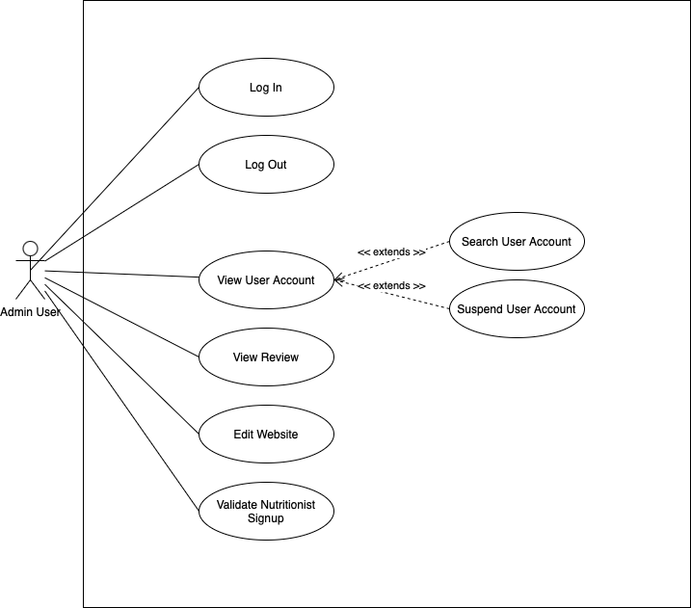

3.5 User Stories- System Admin
- As an admin, I want to view a user account for more details about the user account.
- As an admin, I want to suspend a user account if they have violated any rules or policies.
- As an admin, I want to search for a user account to view that specific user account.
- As an admin, I want to view reviews of the application so I can find out more about user satisfaction.
- As an admin, I want to validate signups from nutritionist users so I can have
- As an admin, I want to edit the project’s website so the information is accurate and up to date.
- As an admin, I want to log in to the system so I can manage the users and web application
- As an admin, I want to log out from the system so I can exit the web application

3.5 Use Case Descriptions- System Admin
Name: VIew user account (Admin User) | ID: AS01
Stakeholders and goals: Admin user can successfully view user accounts
Description: An admin user need to view user account details
Actors: Admin User
Trigger: This event will be triggered when the admin user clicks on view user button
Normal Flow:

- The admin user will click on the view user button
- System will show user form details

Sub-Flows: None
Alternative/Exceptional Flows: None

Name: Delete user account (Admin User) | ID: AS02
Stakeholders and goals: Admin user can successfully delete user accounts
Description: An admin user need to delete user account
Actors: Admin User
Trigger: This event will be triggered when the admin user clicks on delete user button
Normal Flow:

- The admin user will click on the delete user button
- System will prompt a confirm/cancel button
- Admin user will click on confirm button
- System will show user successfully deleted message
- User list updated

Sub-Flows: None
Alternative/Exceptional Flows:
3a. Admin user click on cancel
4a. System will show user not deleted message

Name: Search user account (Admin User) | ID: AS03
Stakeholders and goals: Admin user can successfully search user accounts
Description: An admin user need to search user account
Actors: Admin User
Trigger: This event will be triggered when the admin user clicks on search user button
Normal Flow:
- The admin user will type user name
- Admin user will click on the search user button
- System will display user profile
Sub-Flows: None
Alternative/Exceptional Flows:
3a. System will display no such user found

Name: Validate Nutritionist Sign-Ups | ID: AS04
Stakeholders and goals: Admin User ensures that only qualified nutritionists are approved for the platform.
Description: Admin User can review and validate nutritionist sign-up applications to maintain the platform's credibility.
Actors: Admin User
Trigger: Admin User selects the “Validate Nutritionist Sign-Ups” option.
Normal Flow:
- A new nutritionist application is received.
- The admin user reviews the applicant's details, including qualifications and certifications.
- The admin approves or rejects the application.
- The app notifies the applicant of the decision.
Sub-Flows: None
Alternative/Exceptional Flows: None

Name: Edit the Project Website | ID: AS05
Stakeholders and goals: Admin User can update and maintain the project website to ensure accurate and up-to-date information.
Description: Admin User can make changes to the website content, such as updating text, images, or videos.
Actors: Admin User
Trigger: Admin User selects the “Edit Website” option.
Normal Flow:
- The admin user logs into the website's admin panel.
- The admin selects the section or page to edit.
- The admin makes the necessary changes (e.g., updating text, images, or layout).
- The admin saves the changes.
- The app updates the website and confirms the changes.
Sub-Flows: None
Alternative/Exceptional Flows:
1a. If the admin encounters errors while editing, the app logs the issue and suggests troubleshooting steps.
1b. If the changes fail to save, the app notifies the admin and allows retrying.

Name:Login (Admin User) | ID: AS06
Stakeholders and goals: Admin user can successfully login
Description: An admin user need to login before using the system
Actors: Admin User
Trigger: This event will be triggered when the admin user clicks on the login button
Normal Flow:

- The admin user will click on the login button
- System shows the login form
- Admin user will enter login details
- System will validate the details
- Admin user will be logged in

Sub-Flows: None
Alternative/Exceptional Flows:
4a. System is unable to validate user
5a. Admin user is not logged in

Name:Logout (Admin User) | ID: AS07
Stakeholders and goals: Admin user can successfully logout of the system
Description: An admin user want to logout
Actors: Admin User
Trigger: This event will be triggered when the admin user clicks on the logout button
Normal Flow:

- The admin user will click on the logout button
- Admin user successfully logout

Sub-Flows: None
Alternative/Exceptional Flows: None

4. Non-functional Requirements

4.1 Security Requirements
Security requirements ensures the protection of user data through secure access controls, encryption and authentication. As our system stores user data, the system must prevent unauthorized access, comply with regulations, and safeguard user information from cyber threats. This includes and are not limited to user authentication mechanisms, secure data storage, and regular security assessments to maintain the integrity and confidentiality of the data in our system.

4.2 Reliability Requirements
Reliability requirements defines the system’s ability to function consistently without failure. The application should maintain high availability, prevent data loss, and recover quickly from failures. There should be mechanisms in place for data backup, failover strategies and error handling to ensure uninterrupted service and to meet uptime expectations.

4.3 Performance Requirements
Performance requirements focuses on how efficiently the system should operate under different conditions. It includes response time, load-handling, and resource usage optimization. The application should provide fast interactions, low-latency responses and support concurrent users while maintaining smooth performance without crashes or slowdowns.

4.4 Maintainability Requirements
Maintainability requirements specifies on the ease of updating, debugging and modifying the application. The system should have a well documented code, and scalable architecture. It should facilitate further future improvements, troubleshooting and bug-fixes with minimal downtime to ensure long-term sustainability and adaptability.

4.5 Scalability Requirements
Scalability requirements refers to the system’s ability to handle growth in users, data and processing demands without performance failure. The application should support dynamic scaling, load balancing and optimize database queries. It should efficiently manage increased workload such as new users/data, ensuring consistent performance over all platforms as demand rises over time.

4.6 Usability Requirements
Usability requirements defines how user-friendly and intuitive the application is. The interface should be easy to navigate, responsive and accessible to our users. It should follow industry guidelines. Clear user feedback and error-handling should enhance the overall user experience and engagement.

